Chiplet-Based Architecture Prototype
EECE 490AW | Senior Project | Fall 2025

Jonathan Ekman
Electrical Engineering
California State University, Chico

Brenden Moran
Computer Engineering
California State University, Chico

Executive Summary
As society becomes more connected and reliant on technology, the need for large amounts of computational resources has become a pressing issue. Since computers were made using silicon based chips they have followed a clear pattern. Every two years would see a doubling of transistors on a chip within the same amount of space. Along with this trend there was also a constant amount of power needed for a select area of silicon, meaning that increased transistor density allowed for more performance without a power increase. These trends were called Moore's law and Dennard scaling. Around 2005 these trends broke down, designers could no longer scale their CPU cores performance with clock speed. The only way to generate more computing power is with increasingly novel solutions to the current computing demands. Historically these challenges were solved by increasing the core count and optimizing the core. More recently there has been demand for matrix processing to speed up large language models.
This project aims to create an easily modifiable CPU in verilog to test performance gains with custom instructions and or coprocessors for the purposes of academic study.

Acknowledgements
EECE Department Faculty:
Dr. Reza Khani
Dr. Hadil Msutafa
Dr. Zhaohong Wang

EECE Department at CSU Chico for loaning FPGAs
All peers in EECE 490 AW

Table of Contents
- Executive Summary
- Acknowledgements
- Table of Contents
- List of Figures
- List of Tables
- Nomenclature
- Main Body
  - Background and Introduction
    - Moore’s Law
    - Dennard Scaling
  - Problem Definition
    - Motivation
    - Customer Requirements
    - Engineering Specifications
    - Success Criteria
  - Alternative Concepts
    - FPGA Platform Alternatives
    - Memory Architecture Alternatives
    - Processor Architecture Alternatives
  - Design Solution
    - System Overview
  - Verification Strategy
    - Unit-Level Verification
    - Simulation Environment
  - Planning
    - Project Timeline
  - Budget
    - Material and Tooling Costs
    - Labor Estimates
  - Justification of Design Solution
  - Safety, Welfare, and Public Health Considerations
  - Summary and Proposed Future Actions
- References
- Appendices

List of Figures
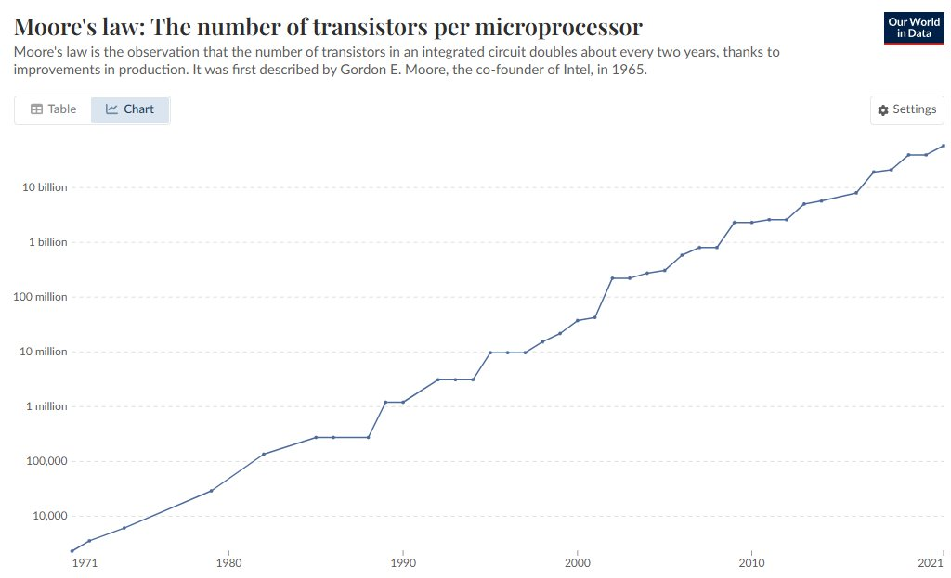
Fig. 1: Moore’s law trend from 1970 to 2021.

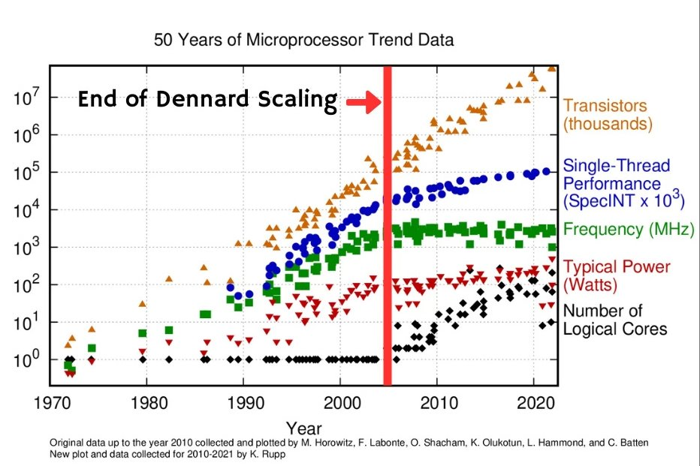
Fig. 2, Dennard Scaling trend from 1970 to 2021.

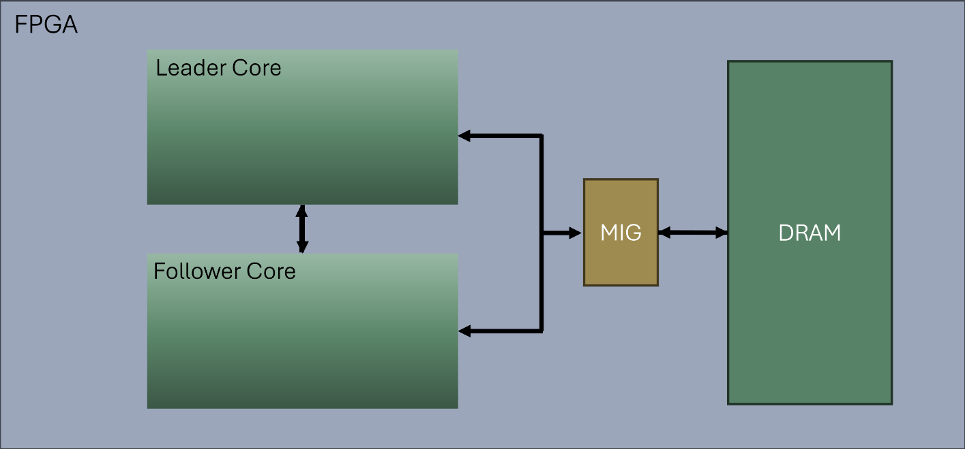
Fig. 3: Simplified block diagram of designed system that will be synthesized on Nexys 4 DDR.

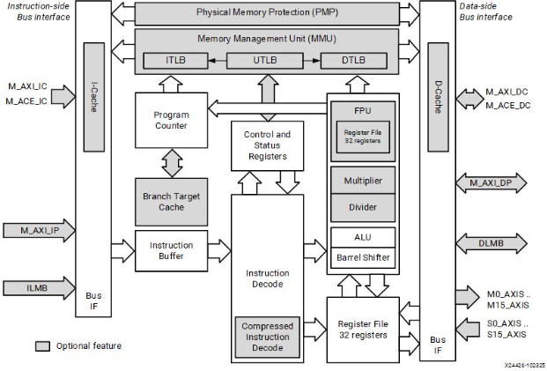
Fig. 4: Block diagram of MicroBlaze V taken from AMD’s website [4].

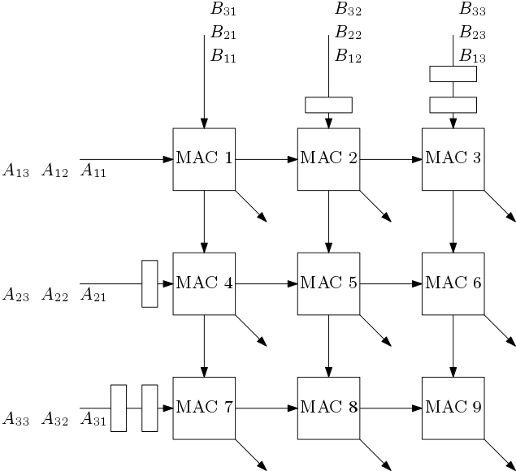
Fig. 5: Systolic matrix multiplier.

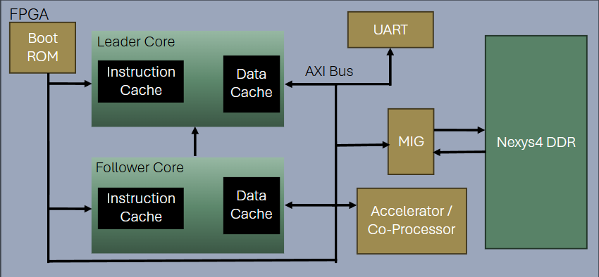
Fig. 6: Complete block diagram of designed system that will be synthesized on Nexys 4 DDR.

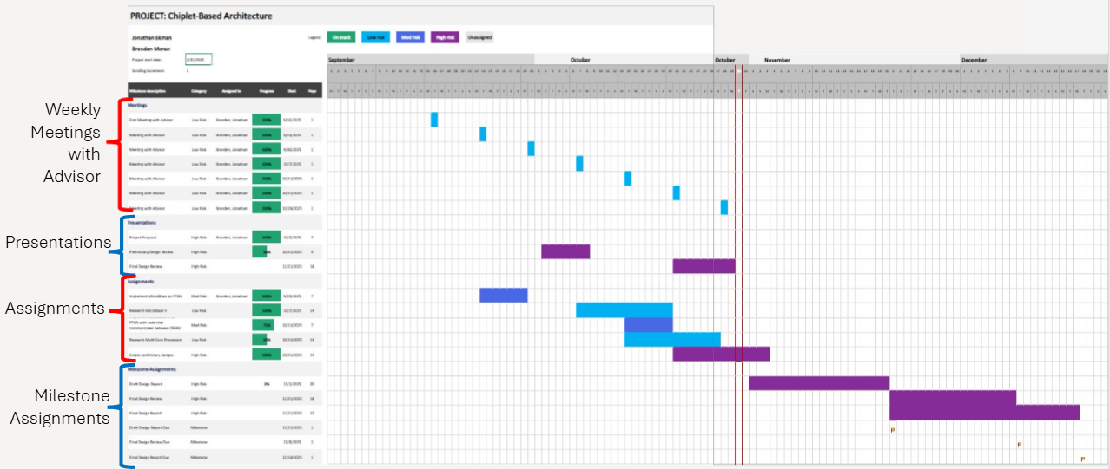
Fig. 7, Completed Gantt chart for Fall semester.

List of Tables
Table 1: Specific values that are achievable through this project.
Requirement | Target
Clock Frequency | > 50 MHz on Nexys 4 DDR
Resources Used | < 50% LUTs, < 50% BRAM, < 20 DSPs on Nexys 4 DDR (~63,000 LUTs, 135x36 Kb blocks, and 240 DSP slices)
Boot Time | Core initialization < 10 ms

Table 2: Project risks, their impacts, and the mitigation tactics behind them.
Risk | Impact | mitigation
Running out of time | Project unfinished or poorly done | Project planning with extra time in mind and clear set goals
AXI contention | Performance degradation | Workload partitioning
Hardware misuse | Potential FPGA damage | Clear documentation with recommended FPGA models
Security vulnerabilities | Data corruption | NIST CSF-aligned memory handling

Nomenclature
CPU - Central Processing Unit
IC - Integrated Circuit
LLM - large language model
SoC - System on a Chip
AXI - Advanced eXtensible Interface
FPGA - Field Programmable Gate Array
LUT - Look-up Table
RISC-V - Reduced Instruction Set Computing
HDL - Hardware Description Language
RTL - Register Transfer Level
ASIC - Application Specific Integrated Circuit
BRAM - Block Random Access Memory

Main Body

Project Background
Silicon-based integrated circuits (ICs) have historically improved in performance and efficiency by following two key industry trends: Moore’s Law and Dennard scaling.
Moore’s Law predicted that the number of transistors on an integrated circuit would double every 2 years, driving exponential increases in computational density and capability as seen in Fig. 1.

Fig. 1: Moore’s law trend from 1970 to 2021.
For decades, this trend held with remarkable consistency and served as the backbone of performance scaling in silicon electronics.
Parallel to this, Dennard scaling (1974) stated that as transistors became smaller, their power density would remain constant. This allowed clock frequencies to rise steadily without causing prohibitive heat generation. However, around 2005, Dennard scaling effectively broke down, an event often referred to as hitting the “power wall” which is clearly seen in Fig. 2.

Fig. 2, Dennard Scaling trend from 1970 to 2021.
Below this threshold, shrinking transistors no longer reduced power proportionally. The transistors were becoming so small that any smaller and the electrons would jump the gap of the gate rendering it useless.
These combined effects marked a hard limit for traditional silicon IC performance. Clock frequencies plateaued, and heat density made further increases unsustainable. As a result, designers could no longer rely on process scaling to deliver straightforward performance improvements.
Instead, architectural innovation became the primary path forward. Long-established techniques such as caching, branch prediction, pipelining, and instruction-level parallelism remained essential but offered diminishing returns. Engineers looked towards multicore architectures as the dominant means of increasing throughput. More recently, designers have integrated specialized accelerators, (for example, matrix-multiplication units optimized for machine-learning workloads) directly into CPUs to compensate for stagnating general-purpose performance.
Together, these trends illustrate a shift from relying on transistor scaling to relying on architectural specialization and parallelism as silicon technology approaches its physical limits.

Problem Definition
The continued reliance on silicon-based processors presents a growing challenge for academic researchers and engineers who seek to investigate new architectural strategies for improving computational performance. As transistor scaling approaches fundamental physical limits, further increases in clock frequency are no longer feasible, shifting the focus toward architectural modifications such as custom instructions, coprocessors, and multi-core designs. However, commercially available processors do not provide the flexibility or accessibility needed to experiment with these architectural features at a low level. To support academic exploration in this area, there is a need for a fully modifiable processor testbed that allows controlled experimentation with CPU architecture, instruction-set extensions, and system-level enhancements within a realistic hardware environment.
The project is designed to be used primarily by academics to study architectural improvements to current CPU designs. They are expected to understand the basics of computer architecture and FPGA programming. They are to have their own computer with Vivado and a compatible FPGA to experiment with the project. Additionally the project will be limited based off the FPGA being used. Many of the budget friendly options for Vivado compatible FPGAs lack specific features, such as cache coherency fabric, to aid in the design of a more thorough CPU. FPGAs also have a limited number of LUTs meaning some users may be restricted on the size of their designs. Furthermore FPGAs have a speed rating and are not guaranteed to perform the circuit stably at higher speeds.
From a customer standpoint, the essential requirements of such a platform include a high degree of flexibility, allowing users to reconfigure or replace CPU components such as ALUs, pipeline stages, coprocessors, or custom instructions. Support for multi-core operation is required so that researchers may evaluate shared-memory architectures and inter-core communication. The platform must maintain compatibility with widely used FPGA development tools to ensure accessibility to students and researchers. Finally, it must offer comprehensive documentation that enables new users to understand, modify, and extend the design without requiring specialized knowledge beyond typical engineering coursework. Collectively, these requirements define a platform that is flexible, accessible, and academically useful.
To meet these needs, the design must adhere to a set of engineering specifications that guide its development. The complete System on Chip (SoC) must fit within the logic, memory, and DSP constraints of the Nexys 4 DDR FPGA board. The processor chosen must implement a RISC-V architecture to ensure openness, modifiability, and compliance with modern academic standards, while also supporting custom instruction integration and AXI-based peripheral communication. The system must operate at a stable and synthesizable clock frequency while maintaining reliable timing closure. The memory subsystem must include a shared system memory accessible by all cores through an AXI or equivalent interconnect architecture. Additionally, the design must incorporate a deterministic initialization mechanism, using a single ROM image from which one core operates as a master to configure any subordinate cores. Finally, the system must include a functional coprocessor interface that enables custom hardware accelerators to interact with the CPU and system memory. These specifications are made more explicit in Table 1 below, where each specification has a target value that the project’s goal is to meet.
Table 1: Specific values that are achievable through this project.
Requirement | Target
Clock Frequency | > 50 MHz on Nexys 4 DDR
Resources Used | < 50% LUTs, < 50% BRAM, < 20 DSPs on Nexys 4 DDR (~63,000 LUTs, 135x36 Kb blocks, and 240 DSP slices)
Boot Time | Core initialization < 10 ms
The project will be considered successful when the resulting platform demonstrates stable, functional operation and supports architectural experimentation as intended. Specifically, the system must successfully boot and execute compiled C programs on at least one RISC-V processor core. It must support the addition and correct execution of custom instructions or simple coprocessor modules. A multi-core configuration must also initialize and operate correctly, with one core coordinating the startup of additional cores. The design must compile and run on the FPGA without critical timing violations at the intended clock frequency. Furthermore, the system’s documentation must enable external users to modify or extend the architecture without outside assistance. A final measure of success is the ability to quantify performance differences between baseline and modified architectures using the testbed, demonstrating its value as an academic and research tool.

Alternative Concepts
Several architectural and tooling alternatives were considered during the concept development phase. FPGA platform alternatives such as Intel FPGAs using Quartus were evaluated, but the Vivado toolchain offers superior debugging features and clearer integration with AXI-based subsystems.
Alternative memory models—including partitioned per-core memory or multiple ROMs—were also considered. While these approaches simplify localized execution, they complicate system scalability and hinder the evaluation of shared-memory contention, which is a core objective of this project.
Processor alternatives, such as Rocket or VexRiscv RISC-V soft cores, offer open-source implementations but require significantly more infrastructure to support multicore booting, memory protection, and debugging. In contrast, MicroBlaze V provides built-in RISC-V compatibility, configurability, and Vivado-native support, making it the most appropriate choice for this academic platform.

Design Solution
The design centers on the MicroBlaze V processor, a publicly available Vivado implementation of a RISC-V architecture. MicroBlaze V uses a Harvard architecture, meaning instruction and data memories are physically separate. This structure enables simultaneous instruction fetch and data access, improving pipeline efficiency and simplifying custom-instruction integration. A high-level block diagram representing the internal components of the FPGA, including processor cores, system memory, and peripheral interconnects, is shown in Fig. 3.

Fig. 3: Simplified block diagram of designed system that will be synthesized on Nexys 4 DDR.
Furthermore, a detailed architectural representation of the MicroBlaze V core, illustrating its configurable internal structure, is provided in Fig. 4.

Fig. 4: Block diagram of MicroBlaze V taken from AMD’s website [4].
These figures aid in understanding how the design leverages the extensibility of the MicroBlaze V to support custom instructions, additional cores, and hardware accelerators.
In its baseline configuration, the system contains a single MicroBlaze V core. However, the architecture is intentionally designed to support multiple cores, and this project specifically implements a second MicroBlaze V core to enable experimentation with multi-core behavior. When multiple processors are instantiated, all cores initialize using a shared ROM image. Each core identifies itself with the special machine hardware thread id register. Each core possesses a unique ID allowing the singular boot ROM to send each core to different programs that can communicate with each other using multi-core mechanisms such as mutexes.
In addition to multi-core capability, the design supports the integration of hardware accelerators. For the purposes of this project, a dedicated matrix-multiplication coprocessor is incorporated into the system. This accelerator connects to the CPU through the AXI bus and is exposed to software as a memory mapped device. Since it performs a tightly scoped computational task, the coprocessor does not require an initialization ROM and may operate with or without dedicated system memory depending on performance needs. The integration of this coprocessor enables the analysis of hardware-accelerated operations, which is central to understanding performance improvements relevant to modern workloads such as machine-learning inference.
MicroBlaze V natively supports custom instruction integration, which allows the processor to issue specialized commands to the connected coprocessor. These custom instructions provide an interface between the core and an AXI device. Instructions and accelerators can be incorporated using the same mechanism, making the system highly expandable. Although this project focuses specifically on a matrix-multiplication unit and a second processor core, the design remains open-ended to allow future expansion. Possible enhancements include additional specialty coprocessors, deeper pipelining of existing units, or the incorporation of more sophisticated inter-core communication structures. A simple block diagram of this matrix multiplier circuit can be seen below in Fig. 5.

Fig. 5: Systolic matrix multiplier.
The completed project’s block diagram can be seen below in Fig. 6. Where each component is connected and synthesized onto the FPGA fabric.

Fig. 6: Complete block diagram of designed system that will be synthesized on Nexys 4 DDR.
Finally, the project includes a detailed guide outlining system configuration, build procedures, and methods for modifying the processor architecture. This documentation is intended to support academic users in understanding and extending the design, enabling experimentation with CPU features, coprocessor behavior, and architectural modifications.
To ensure safety in this design, access control and secure bitstream handling must be considered. Though risks of physical harm are minimal, reliability concerns include metastability, proper reset synchronization, and avoiding undefined AXI signaling. The platform’s emphasis on FPGA-based prototyping reduces environmental harm otherwise associated with silicon fabrication.

Verification Strategy
To ensure correctness in system design and functionality, specific testbenches and other tools will be used to verify the system. This will include unit-level tests to verify specific AXI transactions and confirm that the MicroBlaze V is interfacing with the shared memory correctly. This will be done by viewing the cache and local memory of each MicroBlaze V to verify the system is moving the data between each processor core and memory correctly.
The simulation environment used in this project is Vivado’s XSIM where each testbench will be in agreement with IEEE 1800 standards for SystemVerilog. The testbench will also give the ability to enable/disable certain functions of the MicroBlaze V, this gives the ability to easily see the difference in performance between certain configurations versus others. The goal of this testbench is to have a set piece of hardware that can be easily changed to alter the configurations of all components in the system, such as configuring the MicroBlaze V or altering the connected accelerator with custom instructions. This way the user can easily see the difference in performance from one configuration to the other.

Project Planning
The project’s timeline consists of two halves. The first half falls during the Fall semester where the focus is to complete the theoretical design which provides a solution for the given issue. This is done by identifying the problem and why it needs a solution.
The project incurs many risks that must be mitigated in order for the design and implementation to go well. Each risk, how it could impact the project, and how it should be handled is simplified in Table 2 below.
Table 2: Project risks, their impacts, and the mitigation tactics behind them.
Risk | Impact | mitigation
Running out of time | Project unfinished or poorly done | Project planning with extra time in mind and clear set goals
AXI contention | Performance degradation | Workload partitioning
Hardware misuse | Potential FPGA damage | Clear documentation with recommended FPGA models
Security vulnerabilities | Data corruption | NIST CSF-aligned memory handling

The project at hand is very reliant on time, whether that be with debugging or conducting research to further understand the problem at hand and how to develop a solution to help the targeted customers. The project timeline for the Spring semester is simplified below in Fig. 7, where it is displayed as a complete Gantt Chart.
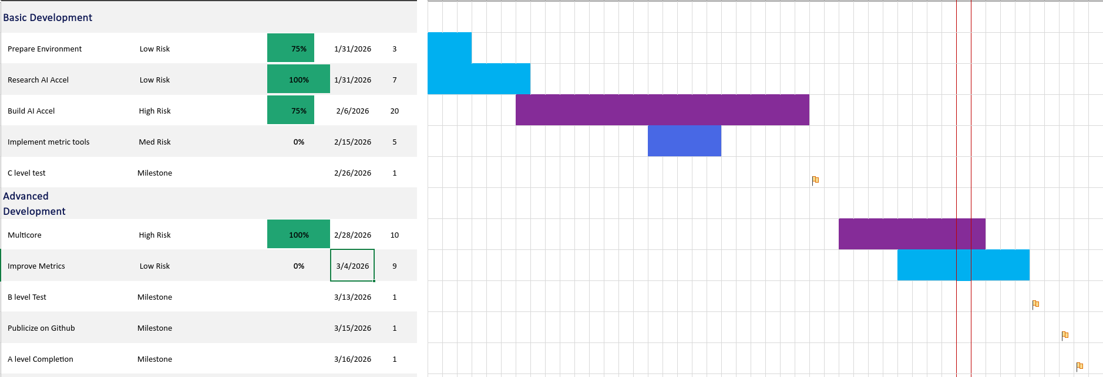
Fig. 7, Completed Gantt chart for Spring semester.
This Gantt chart is separated into main tasks which have their own subtasks attached to each, as well as the main milestones of the Fall semester. These tasks consist of small projects that strengthen understanding of the tools and materials used to complete the project. Some projects include creating a small working prototype of a processor on an FPGA by implementing the MicroBlaze V, this prototype is then used to run a very simple C code.
Other tasks to be completed include research about tools and techniques used in this project. Some research topics include architecture of the MicroBlaze V, Multi-core processors architecture, and standards regarding SystemVerilog in professional engineering projects such as this one.
Overall each semester is done as a 4 unit class which constitutes 12-hours per week on class materials. This over two semesters would be a total of 408 hours, but if including the hours spent during Fall, Winter, and Spring break, the total amount of hours would be closer to 500 hours total. A closer breakdown into the hours needed for this project include 100 hours for research done at the beginning of the Fall semester, 50 hours for preparing and practicing presentations and other deliverable documents in the class. 150 hours for implementing and testing different design ideas as well as their alternatives. As for Spring semester, the goal is to use 100 hours for implementation of the design detailed in this document, followed by 150 for debugging and preparing for the end of the semester Spring Expo.

Project Budget
The budget consists of 3 main parts: material, tooling, and labor. The material and tools used for this project are FPGA boards, specifically the Nexys 4 DDR boards, as well as Vivado design suite. The FPGA boards each cost $350, and a license for the Vivado Design suite version that is used to complete this project is free. Luckily the EECE Department at California State University, Chico allowed us to borrow the Nexys 4 DDR boards for this project. This leaves the total cost for the project's materials and tools being $350 if the customer does not already have an FPGA board to use.
The main cost of this project comes in engineering hours. The total amount of engineering hours estimated for each engineer on the project is 500 hours, this totals 1000 hours to complete the entire project. To estimate the total amount of cost the engineering hours would incur, use the eq. 1 below.

$Total \# Engineering Hours ∗ Avg. Hourly rate = Total Cost$ Eq. 1

This question yields the total cost of engineering hours to be roughly $50,000. Leaving a total estimated cost of this project to be $50,350.

Justification of Design Solution
The selected design solution is justified by its alignment with the customer requirements and engineering specifications established during the problem definition phase. The MicroBlaze V processor was chosen as the foundation of the system because it offers a fully configurable RISC-V architecture that supports custom instructions, modular hardware extensions, and multi-core configurations. These characteristics directly satisfy the need for a modifiable and academically accessible processor platform. Furthermore, the use of a shared-memory AXI-based interconnect ensures that all cores and coprocessors operate within a realistic and industry-standard system architecture, enabling users to evaluate hardware modifications under conditions similar to modern commercial processors.
The integration of a second MicroBlaze V core and a dedicated matrix-multiplication coprocessor further supports the project’s objectives by enabling evaluation of both parallel computation and hardware acceleration. Multi-core support addresses the requirement for architectural experimentation across multiple processing units, while the matrix-multiplication accelerator demonstrates how specialized computational blocks can be added, tested, and benchmarked. Both features adhere to the engineering specifications related to FPGA resource limits, system clock constraints, and memory accessibility. The initialization structure, in which a master core configures subordinate cores before execution, provides a flexible and deterministic mechanism suitable for academic experimentation and aligns with expected RISC-V system behavior.
Finally, the design provides substantial educational and research value. Its modular structure, clear documentation, and compatibility with widely used FPGA development tools make it accessible to students and researchers who require a platform for exploring custom processor architectures. The system’s ability to execute baseline C programs, incorporate new instructions, and evaluate performance differences between modified and unmodified architectural elements demonstrates its effectiveness as a testbed for processor-level experimentation. For these reasons, the chosen design solution successfully addresses the identified problem and provides a practical, extendable foundation for ongoing academic investigation.

Summary & Future Actions
This design will allow academics to far more easily test their ideas for improving computer performance.
Future improvements to the design may include intercepting the execution stage of the microblaze V to improve performance. The current design uses built in custom instructions to implement new instructions. These are generic built-in instructions that allow exposure and capture to and from the AXI bus. In short it requires many instructions to perform one custom instruction. By intercepting the execution stage of the processor it is possible to entirely eliminate wasted clock cycles.

References
[1] “Moore’s law: The number of transistors per microprocessor,” Our World in Data. [Online]. Available: https://ourworldindata.org/grapher/transistors-per-microprocessor. [Accessed: Sept. 30, 2025].
[2] V. Sekar, “How Dennard Scaling Allowed Transistors to Shrink,” Vik’s Newsletter, Jan. 12, 2025. [Online]. Available: https://www.viksnewsletter.com/p/how-dennard-scaling-actually-works. [Accessed: Sept. 30, 2025].
[3] AMD, MicroBlaze V Processor Reference Guide, UG1629. Accessed: Nov. 30, 2025. [Online]. Available: https://docs.amd.com/r/en-US/ug1629-microblaze-v-user-guide/Introduction
[4] AMD, MicroBlaze V RISC-V Processor Overview. Aug. 7, 2025. Accessed: Nov. 30, 2025. [Online]. Available: https://www.amd.com/en/products/software/adaptive-socs-and-fpgas/microblaze-v.html#tabs-97fff0a46c-item-8718b9065d-tab
[5] Arm Ltd., Multi-Core Processors – Arm Developer Documentation. 2025. Accessed: Nov. 30, 2025. [Online]. Available: https://developer.arm.com/documentation/den0013/0400/Multi-core-processors
[6] RISC-V International, Ratified RISC-V Specifications. Accessed: Nov. 30, 2025. [Online]. Available: https://riscv.org/specifications/ratified/
[7] D. S. ROY, “Systolic Matrix Multiplier - Digital System Design,” Digital System Design, Jun. 12, 2020. https://digitalsystemdesign.in/systolic-matrix-multiplier/?srsltid=AfmBOoqyjQQaLkcIR41U4wVGTKRA--KFAkH5htzYwgVsrsxdNYH2Wzjl (accessed Dec. 18, 2025).
[8] IEEE Standards Association, IEEE Std 1800-2017: IEEE Standard for SystemVerilog—Unified Hardware Design, Specification, and Verification Language. Piscataway, NJ, USA: IEEE, 2017.
[9] National Institute of Standards and Technology (NIST), NIST Cybersecurity Framework (CSF) Version 1.1. Gaithersburg, MD, USA: NIST, 2018.
[10] N. Dave, K. Fleming, M. King, M. Pellauer, and Muralidaran Vijayaraghavan, “Hardware Acceleration of Matrix Multiplication on a Xilinx FPGA,” CiteSeer X (The Pennsylvania State University), pp. 97–100, May 2007, doi: https://doi.org/10.1109/memcod.2007.371239.
[11] A. Peiris, “Ashan’s Blog: Digital design of systolic array architecture for matrix multiplication,” Ashan’s Blog, Aug. 01, 2015. https://ashanpeiris.blogspot.com/2015/08/digital-design-of-systolic-array.html
‌

‌

Appendices

Appendix I - I (Gantt Charts Fall)


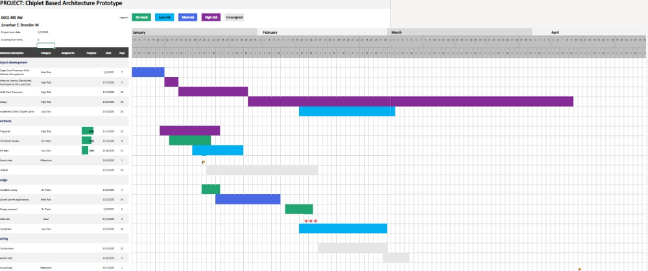

Appendix I I II (Gantt Charts Spring)


Appendix II (Block Diagrams in Vivado Design Suite)
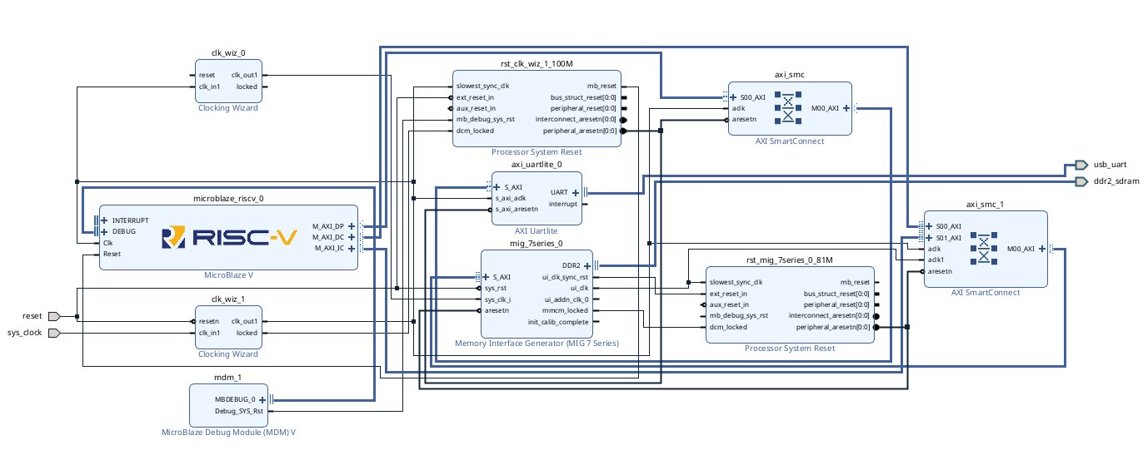
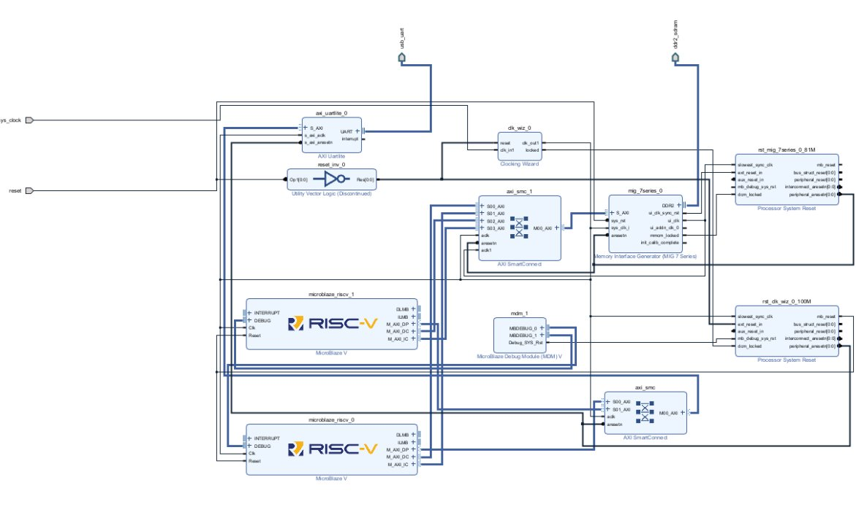

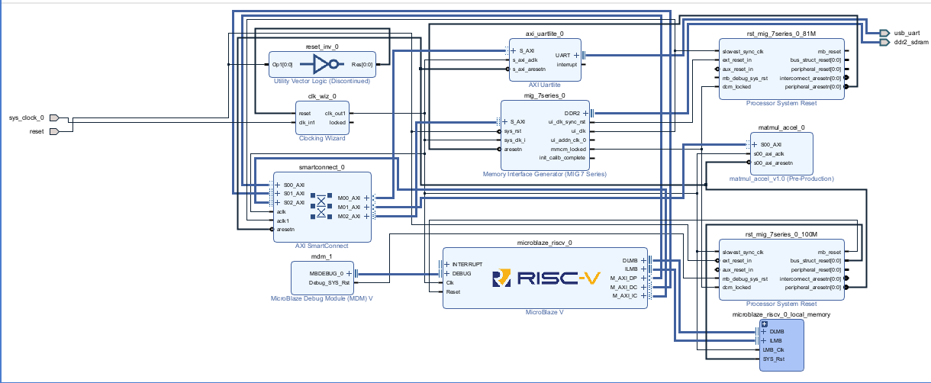

Appendix III (Pugh Analysis of Alternative Components)
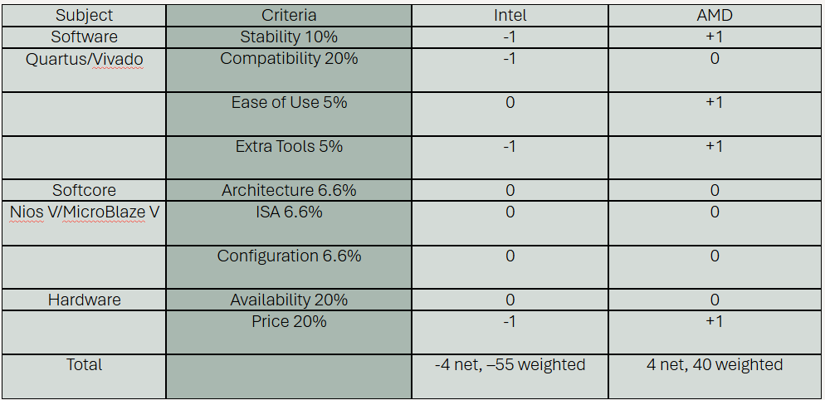

Appendix IV (Previous Block Diagram with Testbench)
